Design and Implementation for a Plant Care System (Bloom)

|  |  |
| --- | --- |
| 2110211 | Layali Adel Khayat |
| 2110808 | Laila Najem Alzahrani |
| 2115044 | Khamsa Saleh Alzahrani |
| 2115094 | Souad Mohammad Amal Ridwan |
| 1914977 | Maryam Maki Shami |

Supervised By

[Dr. Fatmah Assiri]

Department of Software Engineering

College of Computer Science and Engineering

University of Jeddah

Jeddah – Saudi Arabia

(Chapter 1)

# Introduction:

The Kingdom of Saudi Arabia faces numerous challenges in agriculture, despite its essential role as the primary food source. Some people face challenges when they take an interest in agriculture due to ignorance or lack of necessary components like fertile land, water, seeds, and suitable weather conditions, and the overwhelming amount of information they may need. Agriculture is a complex puzzle, and it takes more than just planting seeds and hoping for rain. It needs awareness of different aspects of a plant, weather, environment, watering frequency, adaptation abilities, and more. Therefore, people usually resort to sources that may be incomplete to obtain information about plants or methods of growing them. These sources are usually not rich in sufficient information or are written in another language that the person does not speak. We created a solution that is an efficient, organized, and complete source for all information needed to grow a plant, take care of it, and maintain it in the long run in a simple to understand way. As well as a place to trade necessary resources.

# 1.1 Problem Deﬁnition:

Searching for seeds of specific plants or a method of planting and caring for them is a problem facing many farmers or people interested in plants, especially if there is no complete and reliable source of information.

# 1.2 Aims and objectives:

# 1.2.1 Project Aim:

The goal is to leverage machine learning technology in creating a mobile app where users can access comprehensive plant information and detailed care methods for both agriculture and gardening. Additionally, the app will include a convenient store section offering a variety of agricultural resources.

# 1.2.2 The objectives:

1-To create a centralized source of plant information

2-Providing a user-friendly and straightforward method to research plants

3-Allow users to capture a photo of a plant to identify it.

4- Facilitating resource exchange among users to enhance community collaboration, while also providing a platform to acquire needed physical resources.

# 1.3 proposed solution:

The proposed solution is to develop an application that simplifies the process of obtaining plant information by taking a picture of it with a remainder for watering the plant and it will also help interested users to explore an e-store of planting products that can be exchanged between registered users.

# 1.4 Novelty/Contribution:

* Providing centralized plant information in one source
* Using machine learning technology to simplify searching via image processing and plant identification
* Hosting a resource trading platform for users through an e-store

# 1.5. Report outline:

Report outline

Introduction: 2

1.1 Problem Deﬁnition: 2

1.2 Aims and objectives: 2

1.2.1 Project Aim: 2

1.2.2 The objectives: 3

1.3 proposed solution: 3

1.4 Novelty/Contribution: 3

1.5. Report outline: 3

1.6 Project Plan (Grant chart): 4

1.7. Conclusion: 5

# 1.6 Project Plan (Grant chart):

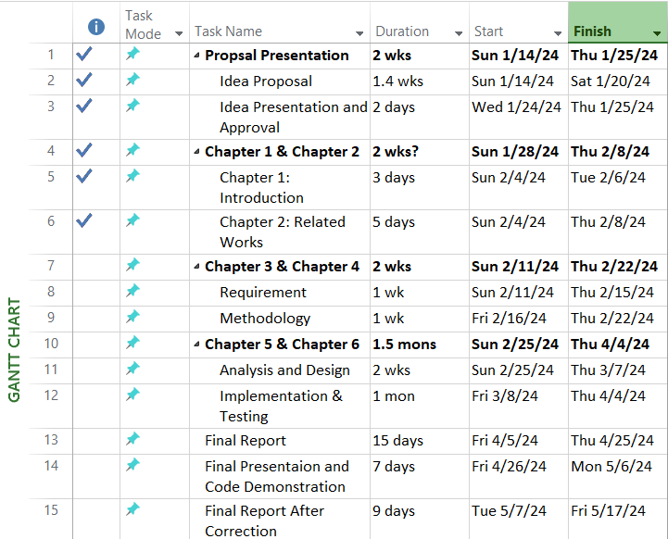

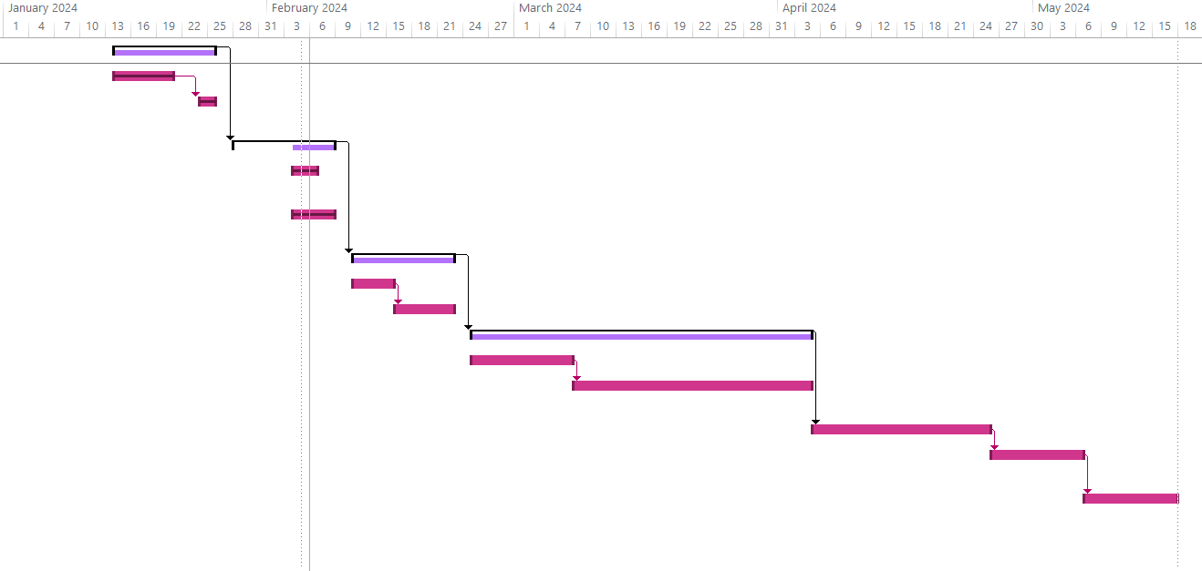

# 1.7. Conclusion:

This chapter is an introduction to our project. Through it, we identified the problem that we have and reviewed it in order to propose the best and most appropriate solution to it, and that is what we arrived at in the proposed solution. Moreover, the aims and objectives of the projects were mentioned, in addition to an attached Gantt chart outlining the progress of the project's tasks.